**Problem Statement**

Unilever, a global leader in consumer goods, operates an extensive supply chain to meet diverse customer needs across multiple regions. The dataset reveals insights into key areas such as revenue generation, inventory management, shipping performance, product quality, and customer demographics. However, several challenges impact Unilever’s supply chain efficiency and profitability:

1. **Revenue Distribution**: Unequal performance across product types calls for deeper analysis to identify top contributors and areas requiring intervention.
2. **Operational Efficiency**: Lengthy lead times and high shipping costs indicate potential inefficiencies in supply chain operations.
3. **Product Quality Issues**: Defect rates in manufacturing suggest opportunities to improve quality control measures.
4. **Inventory Management**: Stock levels need to be monitored to avoid overstocking or stockouts, which impact customer satisfaction.
5. **Logistics Costs**: High shipping costs per order raise concerns about logistics efficiency.
6. **Customer Insights**: Limited visibility into demographic-based revenue prevents effective targeting and strategy optimization.

**Objective**

Developing an interactive dashboard will provide actionable insights into these KPIs, enabling Unilever to:

* Optimize revenue by focusing on high-performing products.
* Streamline supply chain operations to reduce lead times and costs.
* Improve product quality by monitoring defect rates.
* Ensure efficient inventory management to meet customer demands.
* Enhance customer targeting through demographic-based revenue insights.

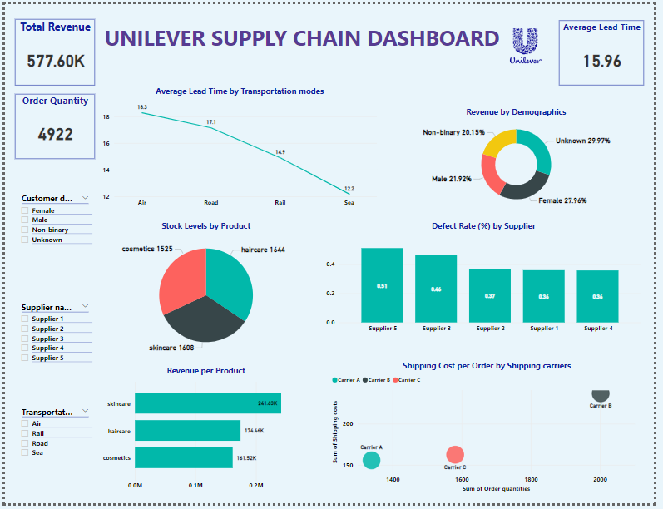

The **Unilever Supply Chain Dashboard** provides a comprehensive view of revenue performance, operational efficiency, and product quality across the supply chain. It effectively highlights key insights, such as top-performing products, customer demographics, lead time inefficiencies, and defect rates, enabling data-driven decision-making. With its diverse visualizations and interactivity, the dashboard meets Unilever's requirements for monitoring and optimizing supply chain performance.

**3. Average Lead Time by Transportation Modes**

* **What It Shows**:
  + The line chart shows the **average lead time (in days)** for each transportation mode, ranging from **Air (18 days)** to **Sea (12 days)**.
  + It highlights which modes of transportation are slower and may impact delivery times. For example, **Air transport**, typically expected to be faster, shows the longest lead time, which could indicate inefficiencies.

**4. Stock Levels by Product**

* **What It Shows**:
  + The **Pie Chart** shows stock distribution across product categories: **Haircare (1644 units)**, **Skincare (1608 units)**, and **Cosmetics (1525 units)**.
  + This KPI helps inventory managers monitor product availability and identify which categories are at risk of overstocking or understocking.

**5. Revenue by Product**

* **What It Shows**:
  + The **Bar Chart** displays revenue contributions from each product category: **Skincare (241.45K)**, **Haircare (174.46K)**, and **Cosmetics (161.52K)**.
  + It highlights the top-performing product categories (e.g., Skincare), helping decision-makers prioritize these products for marketing or resource allocation.

**6. Revenue by Demographics**

* **What It Shows**:
  + The **Pie Chart** categorizes revenue based on customer demographics: **Female (27.96%)**, **Male (21.92%)**, **Non-Binary (20.15%)**, and **Unknown (29.97%)**.
  + This KPI provides insights into customer behavior, helping Unilever tailor its marketing strategies to maximize revenue from specific groups.

**7. Defect Rate (%) by Supplier**

* **What It Shows**:
  + The **Bar Chart** presents defect rates for different suppliers, with **Supplier 5** having the highest defect rate at **0.51%** and **Supplier 4** having the lowest at **0.35%**.
  + This KPI highlights quality control issues, enabling Unilever to engage with underperforming suppliers to improve product quality.

**8. Shipping Cost per Order by Shipping Carriers**

* **What It Shows**:
  + The **Bubble Chart** compares shipping costs across carriers. For instance, **Carrier C** has higher costs associated with larger orders, while **Carrier B** shows minimal costs.
  + This KPI helps identify cost-efficient shipping partners and optimize logistics to minimize shipping expenses.

**Conclusion**

Each KPI is interconnected, providing a holistic view of Unilever's supply chain performance:

* **Revenue KPIs** (e.g., Total Revenue, Revenue by Product, Revenue by Demographics) focus on financial performance and customer insights.
* **Operational KPIs** (e.g., Lead Time, Shipping Cost per Order) evaluate efficiency and cost-effectiveness.
* **Quality KPIs** (e.g., Defect Rate by Supplier) address product reliability and supplier performance.
* **Inventory KPIs** (e.g., Stock Levels) ensure balanced stock availability.